USDI
BUREAU OF INDIAN AFFAIRS

LOG LOAD RECEIPT BOOK

RETURN TO:
U.S. DEPARTMENT OF INTERIOR
Bureau of Indian Affairs

THIS BOOK MUST BE RETURNED
TO BIA FORESTRY WHEN:

- All Woods Receipts have been used.

- During extended sale inactivity.

- During seasonal shutdown.

- At close of sale.

- At the request of the Forest Officer in Charge.

BOOK NO.

INSTRUCTIONS FOR USE

- PURCHASER-OPERATOR: Fill out receipts. Retain Woods Receipt in book.

- DRIVER: Sign Woods Receipt.

- For log trucks, detach and staple Load and Scaler Receipts to bunk or wing log at the front or back of load on the driver’s side. Truck-trailer “mule train” loads require a separate receipt for each trailer.

- For other forest products, staple or attach receipt to a conspicuous location on the vehicle transporting the forest products.

NOTE: Operator – use books in sequence by numbers where sample scale is involved.

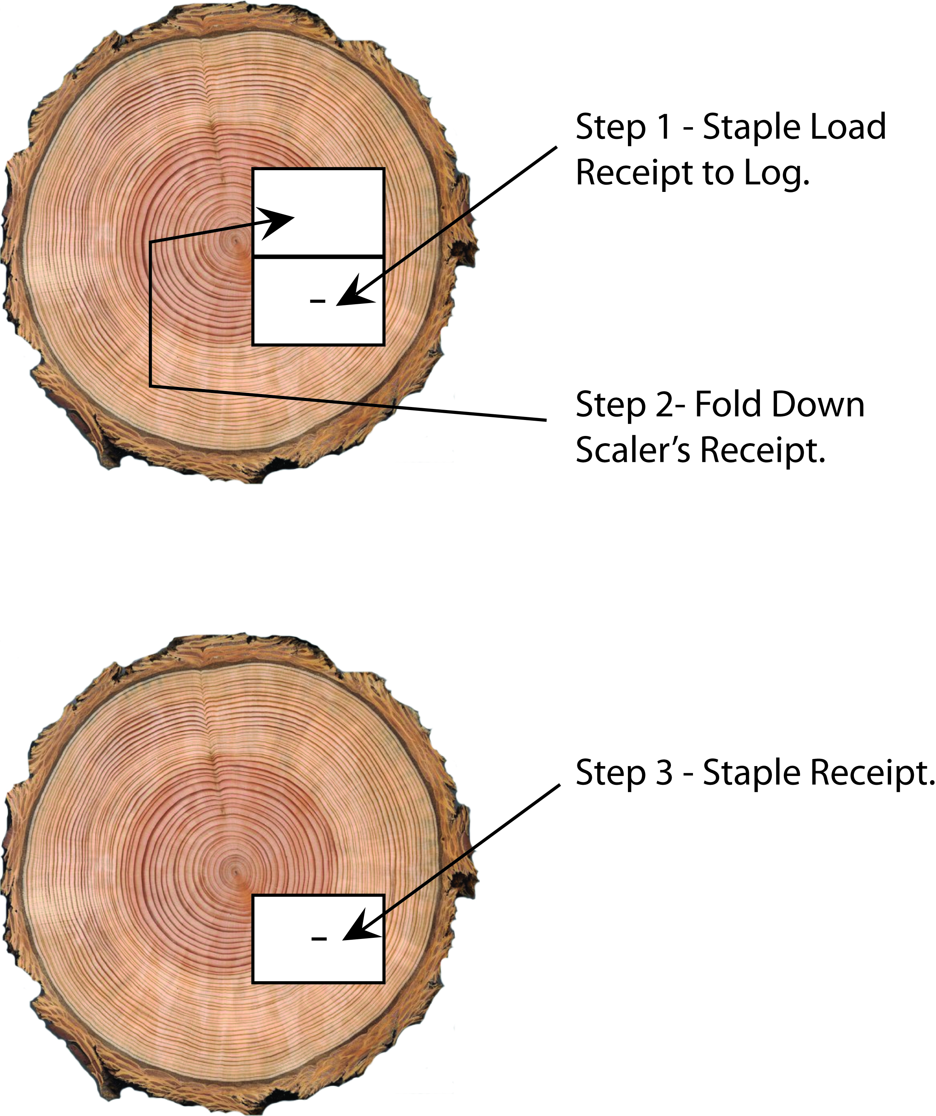

DATE
RECEIVED BY:
NO. OF LOGS
SCALING LOCATION:
SEAL NUMBER
BLOCK NO.

SALE NAME:

SCALING UNIT:
LOG BRAND
DATE
BUREAU OF INDIAN AFFAIRS – WOODS RECEIPT
No.

PURCHASER: FILL OUT TICKETS
RETAIN STUB IN BOOK.

BUREAU OF INDIAN AFFAIRS – TRUCKER RECEIPT

DATE TRUCK NO. No.

BUREAU OF INDIAN AFFAIRS – SCALER RECEIPT No.

SCALER: Detach Scaler Receipt, staple to BIA copy of scale ticket, return daily to address above.

BUREAU OF INDIAN AFFAIRS – LOAD RECEIPT

SCALER RECORD LOAD NO. ON SCALE TICKET.
LOG BRAND TRUCK # NO. OF LOGS

SEAL NUMBER
DRIVERS SIGNATURE
BLOCK NO.
DESTINATION
SALE NAME
SCALING UNIT

SALE NAME
SCALING UNIT
LOG COUNT
BLOCK NO.
No.

PURCHASER: Staple Load and Scaler Receipts to the bunk or wing log at the front or back of load on the driver’s side.
(SEE INSTRUCTIONS)

DATE
Log Load Ticket Procedures

Log Load Receipt Books normally remain on an active sale in accordance with procedures outlined in the contract, harvesting plan, and/or consumer scale agreement. Receipt books must be stored in a secure location (i.e., lockbox). If the book is assigned to a particular truck, then the book will accompany the truck. All portions of the load ticket must be completed before the load leaves the sale area.

Trucks transporting Trust timber can be stopped and checked to verify that the load tickets were completed properly. Penalties for violating consumer scale procedures must be included in the forest products contract or the consumer scale agreement.

The harvesting plan must identify who is authorized to sign for and receive ticket books and who will be responsible for them.

The following are procedures associated with each receipt:

Woods Receipt: will remain attached in the book, enter information that identifies the truck, sale name, scaling unit, date, piece count, load destination, and driver’s signature.
Trucker Receipt: this portion will be issued to the truck driver delivering the log load for their personal records, enter date and truck number.
Scaler Receipt: Date, Sale Name, Block No., Scaling Location, Scaling Unit and No. of logs must be entered. Log Brand and Seal No. will be entered if available and when necessary. For scale loads, this portion will be removed by the log scaler who scales the load. In the “Received By” box, the log scaler scaling the load will initial or sign here and attach to the hard copy log scale sheet or as directed in the Contract, Permit, Harvest Plan or Scaling Agreement. For non-scale loads, this portion will remain attached to the log.
Load Receipt: identifies the truck, Sale name, scaling unit, and date. This portion will be removed at the weigh shack and attached to the hard copy weight ticket which will then be deposited into a BIA lock box.

When a Log Load Truck Receipt Book is issued to a single truck (i.e., self-loader), it will be utilized as described above. The book is always secured and kept in the log truck until returned to the issuing agency as described above.

Procedures for attaching receipts to log load:
Remove the Scaler and Load Receipts from the book, do not separate the two. Secure load receipts either on the front or back of a bunk log, drivers’ side of the load. Using ¾” staples; staple the Scaler Receipt to the bunk log on the upper left- and right- hand corners then on the lower left and right corners, fold the Load Receipt over the Scaler Receipt and staple on the upper right- and left- hand corners.

